September, 2016
Bulletin: TraxxShield100 Loose-lay Installation Methods
On certain installations, it is required to float (loose-lay) TraxxShield100 over the concrete slab or existing floor. This is common on planned floor removal or covering an existing tile floor. However, the installation technique is different.
We know that the installer must leave the Release Liner on TraxxShield100, thereby not sticking to the floor. But taping of the seams requires an adjustment from the standard 2” white TraxxShield Seam Tape. If the installer were to tape the TOP of the seam, seam telegraphing could occur on certain VCT, LVT, and LVP floorcoverings. For this reason, we have introduced TraxxShield Double-Sided Seam Tape.
Two types of installations are recommended with the Double-Sided Tape;
- BOTTOM of the Seam. This BOTTOM-SEAMING is critical for VCT, LVT, and LVP tiles. The installer ensures no seam telegraphing. Follow the standard installation method for Traxxshield100 and adhere the Double-Sided Tape to the floor. Hand roller the tape, remove the tape release paper, and lay the Traxxshield100 into the tape.
- TOP of the Seam. For use when Carpet Tile or Engineered Wood is specified.
It is approved to TOP SEAM with the Double-Sided Tape, as there are no concerns with seam telegraphing.
Reminder: Use the Double-Sided Tape to adhere TraxxShield100 at all thresholds or transitions.
**The Loose-lay installation method is not approved for Sheet Vinyl or Ceramic floorcoverings.
These Double-Sided Seam Tape techniques meet the objectives of floating installations and maintaining excellent seam integrity.
Please order the TraxxShield Double-Sided Seam Tape as Part No. TSU-40200-DST.

TraxxShield Seam Tape Options
- Loose-lay Floating Method for VCT, LVP/LVT (Bottom Seaming)
- Apply Double-Sided TraxxShield Seam Tape to concrete slab and hand-roll.
- Remove tape liner to expose adhesive and fold back both rows of TraxxShield100 back down over seam tape. No Seam Telegraphing!
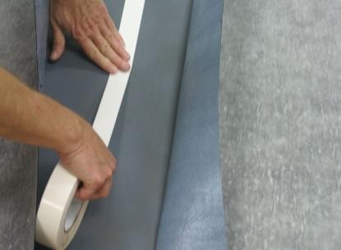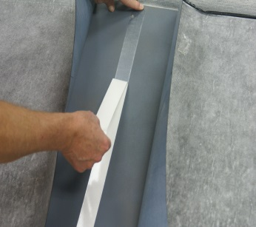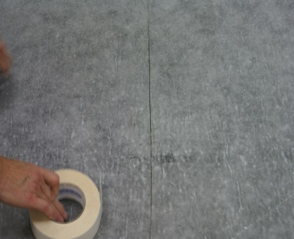
- Loose-lay Floating Method for Carpet Tile and Engineered Wood (Top Seaming)
- Apply Double-Sided TraxxShield Seam Tape to top of seam and hand-roll.
- Remove tape liner, and top seam is quickly created
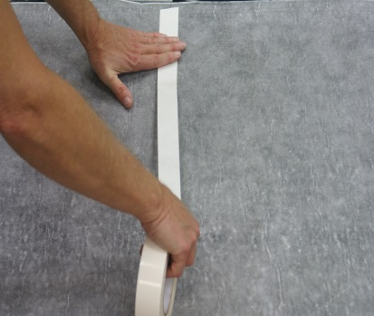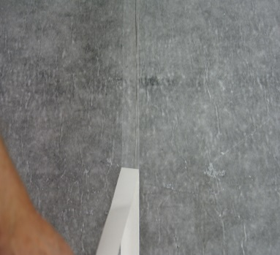
- Standard Peel & Stick Method
- Apply TraxxShield Seam Tape directly to concrete slab.
- Remove Release Liner of TraxxShield100 membrane and fold both rows back down over seam tape. No Seam Telegraphing!
